Gesture Controlled and RFID

           based Home AUTOMATION

TEAM-17

PROJECT MEMBER DETAILS

1. Bhanu Pranaswi - S20210020309
2. Sruthi - S20210020299
3. Sarath Chandra - S20210020317
4. Harshavardhan - S20210020293

**Abstract:**

The following research and project are made to assist physically challenged people themselves to control devices around them. The project includes a glove which is wirelessly connected to various day to day appliances such as lights, fan etc. The communication is achieved through generally available Bluetooth modules. In this project two types of modules are used wherein one of them is attached to gloves which acts as transmitter and the other is attached at the receiver end such as appliance. Thus, an attempt made to help people to use appliance at their convenience

**Introduction:**

There are many ways of controls used in home automation like ZigBee, API’s, cloud based etc. Here we have introduced a new method of control for automation. This method can easily be adapted to real time appliances with minimum variations.

RFID Radio Frequency Identification is a device that refers to the electromagnetic waves having a wavelength suited for use in radio communications. Using RFID, the data can be serially transmitted to communicate. RF is used in many different applications. Such as identification systems, radio, televisions, etc

**Report:**

**CONTROL OF HOME DEVICES BASED ON HAND GESTURE :**

Human-machine interfaces are constantly evolving. Within this group, the interfaces based on natural gestures of users allow converting these movements into commands for a computer system without contacting any surface.

This describes the architectural model of a system that ad- dresses these interfaces to control home automation systems. This device not only combines the measurement of electrical activity produced by the movement of forearm and hand muscles to detect the hand gesture but is also able to capture the orientation and rotation of the movement.

Finally, a study is performed of its real time application to control appliances which can be used by many people.

**CONTROL OF HOME DEVICES BASED ON RFID MODULE:**

The main object of this project is to develop a home automation system with a four-button key fob transmitter by using RF (Radio Frequency) technology. Nowadays, houses are gradually shifting from normal switches to centralized control systems, involving a remote-control transmitter.

This technology is not only easy to use but also helps to prevent misuses of energy. Remote control (key fob) transmitter is small and very light weight, which will work from a decent distance.

To achieve this, a RF remote is interfaced to the microcontroller on the transmitter side which sends ON/OFF commands to the receiver where loads are connected.

By operating the specified remote switch on the transmitter, the loads can be turned ON/OFF remotely through wireless technology. Arduino IDE software has been used to compile some programs related to the microcontroller ATmega328. (Arduino Uno R3)

**Block Diagram:**

1. GESTURE BASED HOME AUTOMATION**:**

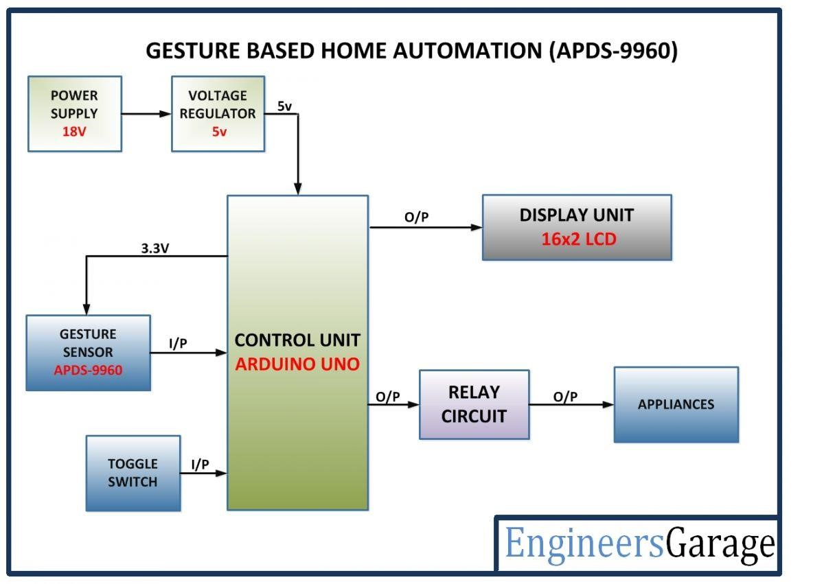

BLOCK DIAGRAM:

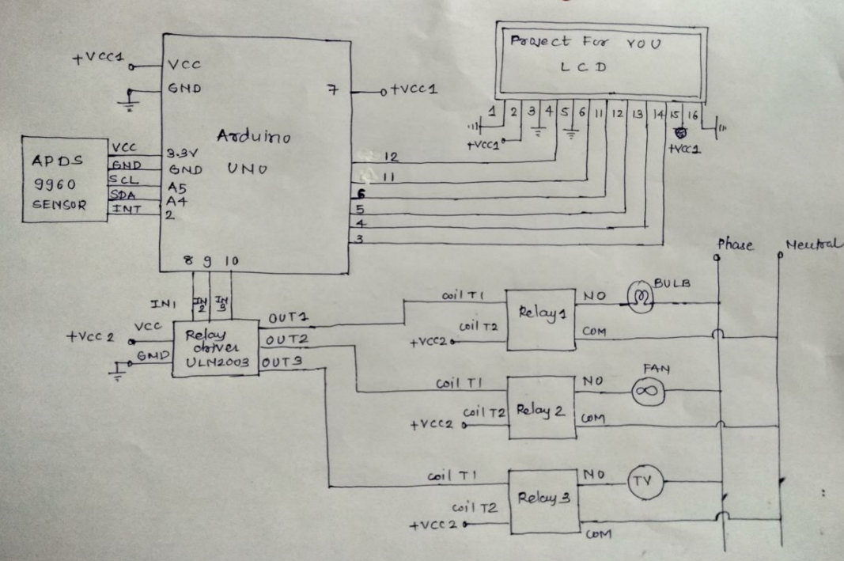

1. RFID BASED HOME AUTOMATION:

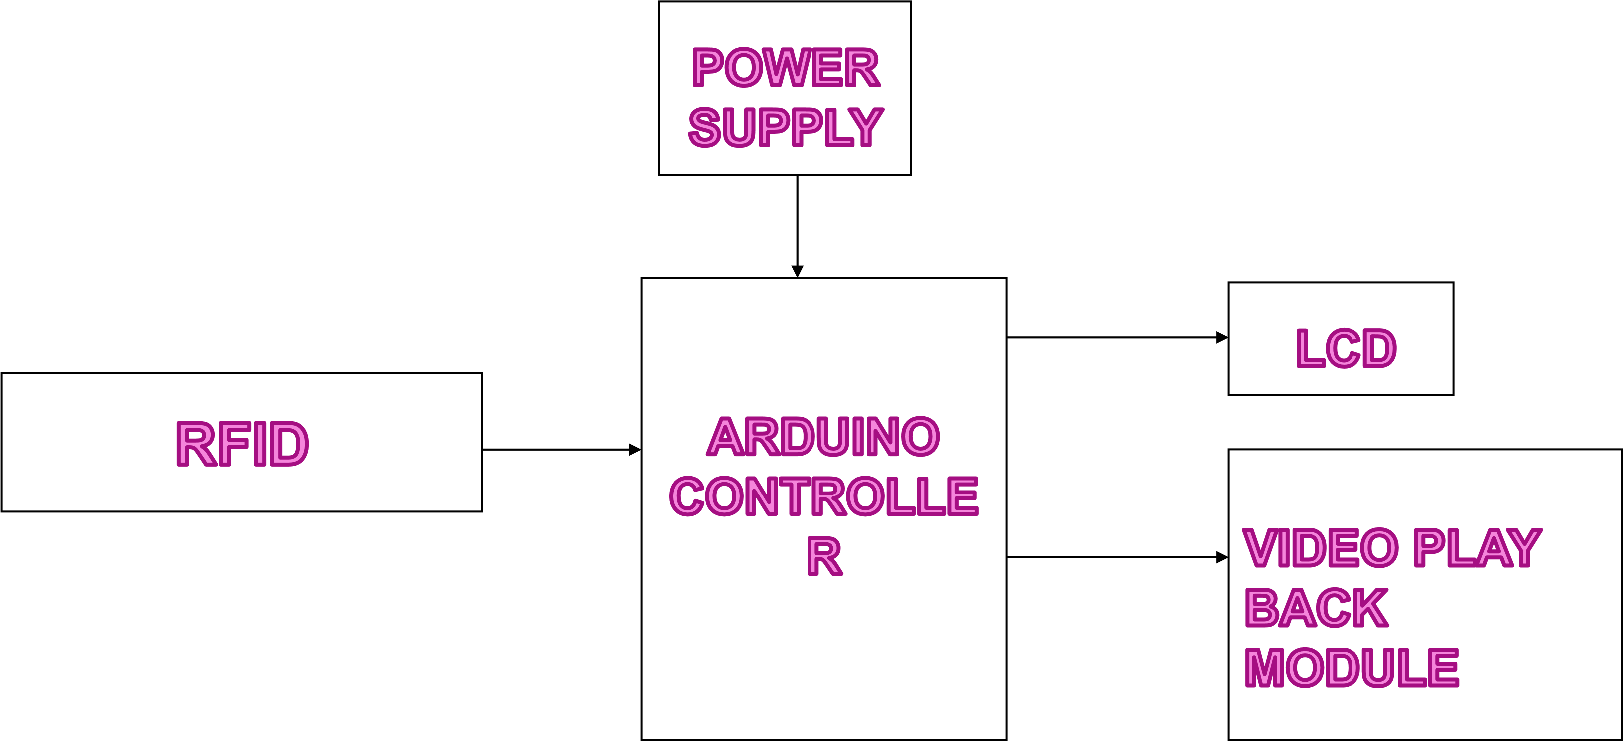

USING MIT APP:

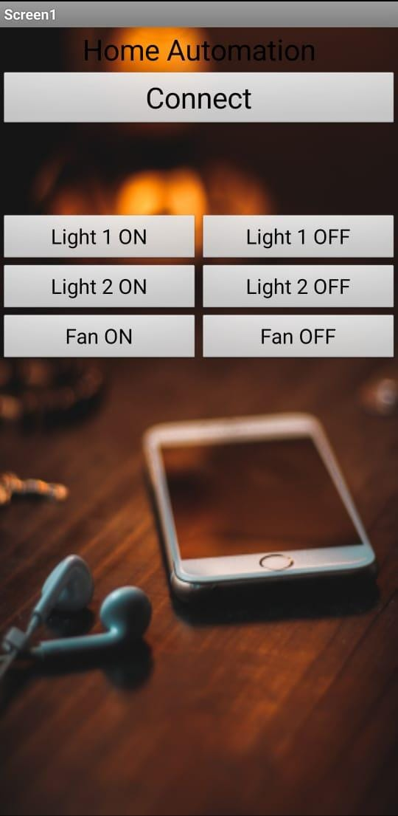

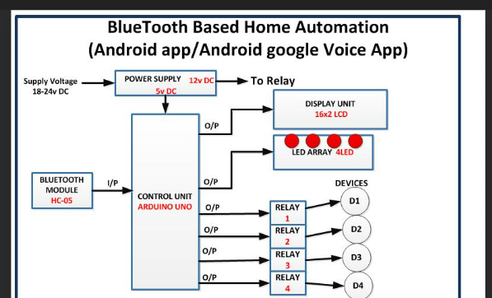

HARDWARE COMPONENTS:

RFID BASED AUTOMATION:

1. Arduino Microcontroller
2. RFID Reader
3. RFID Tags
4. Buzzer
5. Power Supply
6. Connecting Wires

GESTURE BASED AUTOMATION:

1. Arduino UNO

2. 5 mm LED

3. 10K ohm PRESET

4. 12 V Relay

5. Bulbs

6.Fan

7. APDS-9960 gesture sensor

8.Interrupt

SOFTWARE COMPONENTS:

1.Arduino IDE

2.MIT app Inventor

3.Firebase

CODES:

RFID BASED HOME AUTOMATION:

#include <SPI.h>

#include <MFRC522.h>

#define SS_1_PIN 10

#define SS_2_PIN 2

#define RST_PIN 9

int relay1=6;

int relay2=5;

int buzzer = 7;

MFRC522 mfrc522(SS_1_PIN, RST_PIN); // Instance of the class

MFRC522 mfrc522a(SS_2_PIN, RST_PIN); // Instance of the class

MFRC522::MIFARE_Key key;

// Init array that will store new NUID

byte nuidPICC[3];

void setup() {

pinMode(relay1, OUTPUT);

pinMode(relay2, OUTPUT);

pinMode(buzzer, OUTPUT);

Serial.begin(9600); // Initiate a serial communication

SPI.begin(); // Initiate SPI bus

mfrc522.PCD_Init();

mfrc522a.PCD_Init(); // Initiate MFRC522

Serial.println("Approximate your card to the reader...");

Serial.println();

}

void loop() {

RFID();

RFID1();

}

void RFID()

{

//Serial.println("pirmais");

if ( ! mfrc522.PICC_IsNewCardPresent()) { return;}

// Select one of the cards

if ( ! mfrc522.PICC_ReadCardSerial()) {return; }

//Show UID on serial monitor

Serial.print("UID tag :");

String content= "";

byte letter;

for (byte i = 0; i < mfrc522.uid.size; i++)

{

Serial.print(mfrc522.uid.uidByte[i] < 0x10 ? " 0" : " ");

Serial.print(mfrc522.uid.uidByte[i], HEX);

content.concat(String(mfrc522.uid.uidByte[i] < 0x10 ? " 0" : " "));

content.concat(String(mfrc522.uid.uidByte[i], HEX));

}

Serial.println();

Serial.print("Message : ");

content.toUpperCase();

if (content.substring(1) == "11 23 CE 26") //Change the UID of the card/cards that you want to give access

{

Serial.println("Authorized access");

Serial.println();

digitalWrite(relay1, HIGH);

digitalWrite(buzzer, LOW);

delay(3000);

digitalWrite(relay1, LOW);

}

else {

Serial.println(" Access denied");

digitalWrite(relay1, LOW);

digitalWrite(buzzer, HIGH);

delay(3000);

digitalWrite(buzzer, LOW);

}

}

void RFID1()

{

if ( ! mfrc522a.PICC_IsNewCardPresent()) {return; }

// Select one of the cards

if ( ! mfrc522a.PICC_ReadCardSerial()) {return; }

//Show UID on serial monitor

Serial.print("UID tag :");

String content= "";

byte letter;

for (byte i = 0; i < mfrc522a.uid.size; i++)

{

Serial.print(mfrc522a.uid.uidByte[i] < 0x10 ? " 0" : " ");

Serial.print(mfrc522a.uid.uidByte[i], HEX);

content.concat(String(mfrc522a.uid.uidByte[i] < 0x10 ? " 0" : " "));

content.concat(String(mfrc522a.uid.uidByte[i], HEX));

}

Serial.println();

Serial.print("Message : ");

content.toUpperCase();

if (content.substring(1) == "01 48 3F 26") //Change the UID of the card/cards that you want accessto

{ Serial.println("Authorized access");

Serial.println();

digitalWrite(relay2, HIGH);

digitalWrite(buzzer, LOW);

delay(3000);

digitalWrite(relay2, LOW); }

else {

Serial.println(" Access denied");

digitalWrite(relay2, LOW);

digitalWrite(buzzer, HIGH);

delay(3000);

digitalWrite(buzzer, LOW);

}

}

GESTURE BASED HOME AUTOMATION:

#include <Wire.h>

#include <SparkFun_APDS9960.h>

#include<LiquidCrystal.h>

LiquidCrystal lcd(12,11,6,5,4,3);

#define APDS9960_INT 2

SparkFun_APDS9960 apds = SparkFun_APDS9960();

int isr_flag = 0;

int relay1 = 8;

int relay2 = 9;

int relay3 = 10;

int relay4 = 7;

void setup () {

pinMode (APDS9960_INT, INPUT);

pinMode (relay1, OUTPUT);

pinMode (relay2, OUTPUT);

pinMode (relay3, OUTPUT);

pinMode (relay4, OUTPUT);

Serial.begin(9600);

Serial.println();

Serial.println(F("--------------------------------"));

Serial.println(F ("SparkFun APDS-9960 - GestureTest"));

Serial.println(F ("--------------------------------"));

attachInterrupt (0, interruptRoutine, FALLING);

if (apds.init() ) {

Serial.println(F("APDS-9960 initialization complete"));

}

else {

Serial.println(F("Something went wrong during APDS-9960 init!"));

}

if (apds.enableGestureSensor(true) ) {

Serial.println(F ("Gesture sensor is now running"));

}

else {

Serial.println(F ("Something went wrong during gesture sensor init!"));

}

lcd.begin(16,2);

lcd.setCursor(0,0);

lcd.print (" GESTURE BASED ");

lcd.setCursor(0,1);

lcd.print (" HOME AUTOMATION ");

delay (5000);

}

void loop ()

{

lcd.setCursor(0,0);

lcd.print(" WAITING FOR ");

lcd.setCursor(0,1);

lcd.print(" INPUT ");

if (isr_flag ==1) {

detachInterrupt (0);

handleGesture ();

isr_flag = 0;

attachInterrupt (0, interruptRoutine, FALLING);

}

}

void interruptRoutine () {

isr_flag = 1;

}

void handleGesture () {

if (apds.isGestureAvailable() ) {

Serial.println("Detected Gesture....");

switch (apds.readGesture() ) {

case DIR_UP:

{

Serial.println("UP");

digitalWrite (relay1, HIGH);

delay (2000);

lcd.setCursor(0,0);

lcd.print(" HOME AUTOMATION ");

lcd.setCursor(0,1);

lcd.print("BULB1 ON ");

delay (2000);

lcd.clear();

break;

}

case DIR_DOWN:

{

Serial.println("DOWN");

digitalWrite (relay2, HIGH);

delay (2000);

lcd.setCursor(0,0);

lcd.print("HOME AUTOMATION ");

lcd.setCursor(0,1);

lcd.print("BULB2 ON ");

delay (2000);

lcd.clear();

break;

}

case DIR_LEFT:

{

Serial.println("LEFT");

digitalWrite (relay3, HIGH);

delay (2000);

lcd.setCursor(0,0);

lcd.print("HOME AUTOMATION ");

lcd.setCursor(0,1);

lcd.print ("FAN ON ");

delay (2000);

lcd.clear();

break;

}

case DIR_RIGHT:

{

Serial.println("RIGHT");

digitalWrite (relay4, HIGH);

delay (2000);

lcd.setCursor(0,0);

lcd.print("HOME AUTOMATION ");

lcd.setCursor(0,1);

lcd.print("RELAY4 ON ");

delay (2000);

lcd.clear();

break;

}

case DIR_NEAR:

{

Serial.println("NEAR");

digitalWrite (relay1, HIGH);

digitalWrite (relay2, HIGH);

digitalWrite (relay3, HIGH);

digitalWrite (relay4, HIGH);

delay (2000);

lcd.setCursor(0,0);

lcd.print("HOME AUTOMATION ");

lcd.setCursor(0,1);

lcd.print ("RELAY ON ");

delay (2000);

lcd.clear();

break;

}

case DIR_FAR:

{

Serial.println("FAR");

digitalWrite (relay1, LOW);

digitalWrite (relay2, LOW);

digitalWrite (relay3, LOW);

digitalWrite (relay4, LOW);

delay (2000);

lcd.setCursor(0,0);

lcd.print("HOME AUTOMATION ");

lcd.setCursor(0,1);

lcd.print ("RELAY OFF ");

delay (2000);

lcd.clear();

break;

}

default:

Serial.println("NONE");

}

}

}

NOTE:

* Our project is useful at home
* if user wants to operate the appliances using mobile (MIT app) from far distances then node MCU can be used instead of Bluetooth module.

OUTPUT:

Explanation: we tried to make the life of a person easier using RFID and gesture sensor which can be operated from anywhere but only thing is they should have RFID components and a gesture sensor. when user gives the gestures accordingly the appliance will glow.

1)GESTURE BASED HOME AUTOMATION:

**Output in serial monitor:**

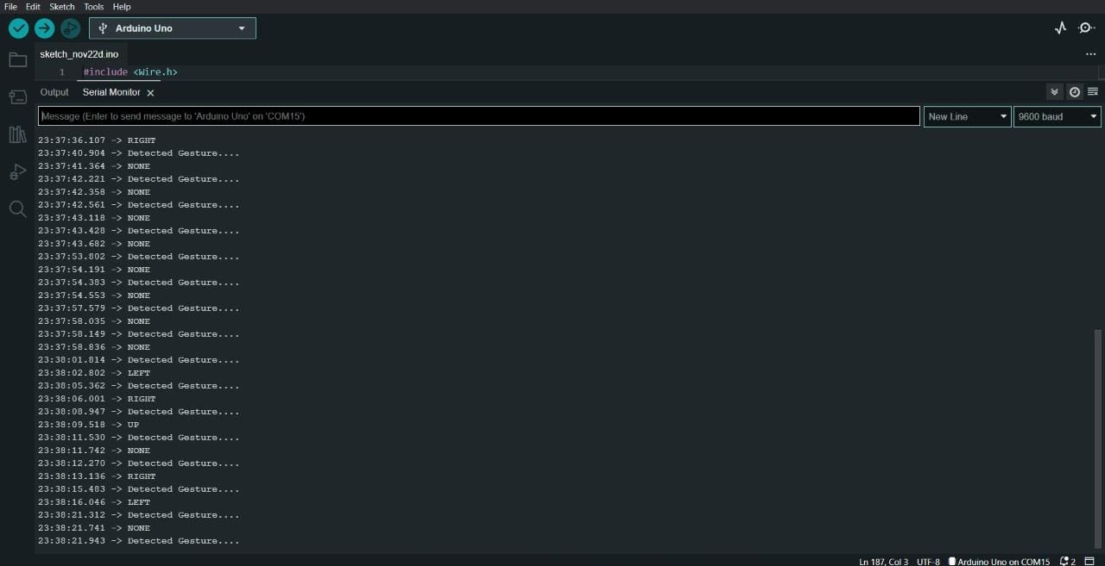

**LCD 1. L**

**LCD display:**

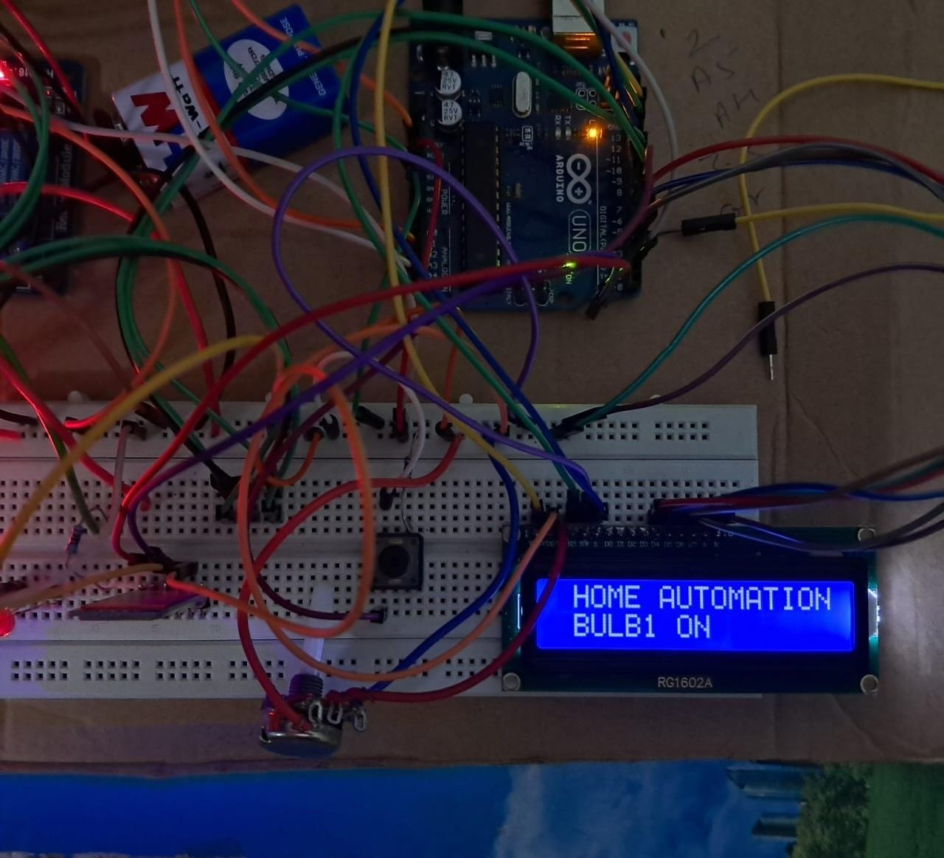

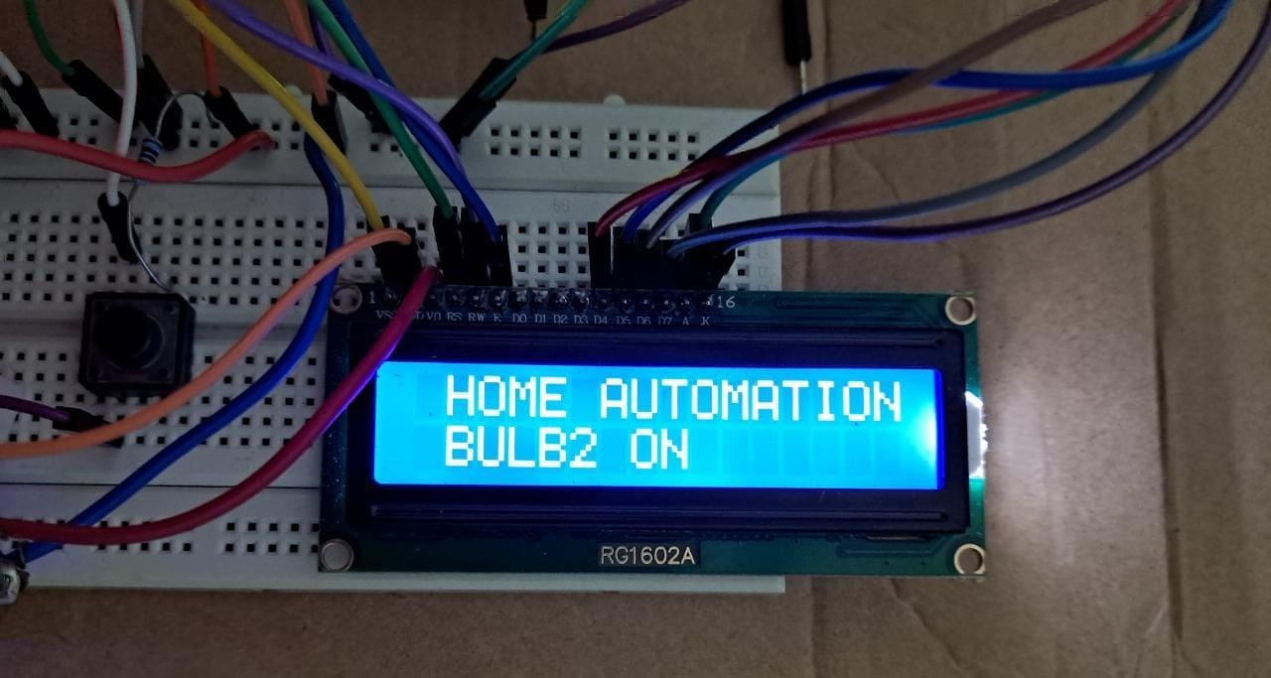

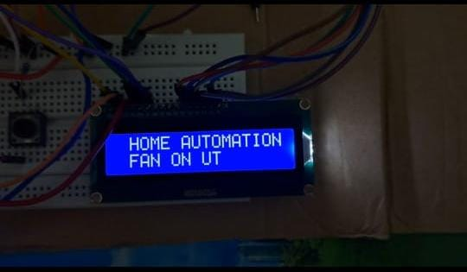

RFID BASED HOME AUTOMATION

**Output in serial monitor:**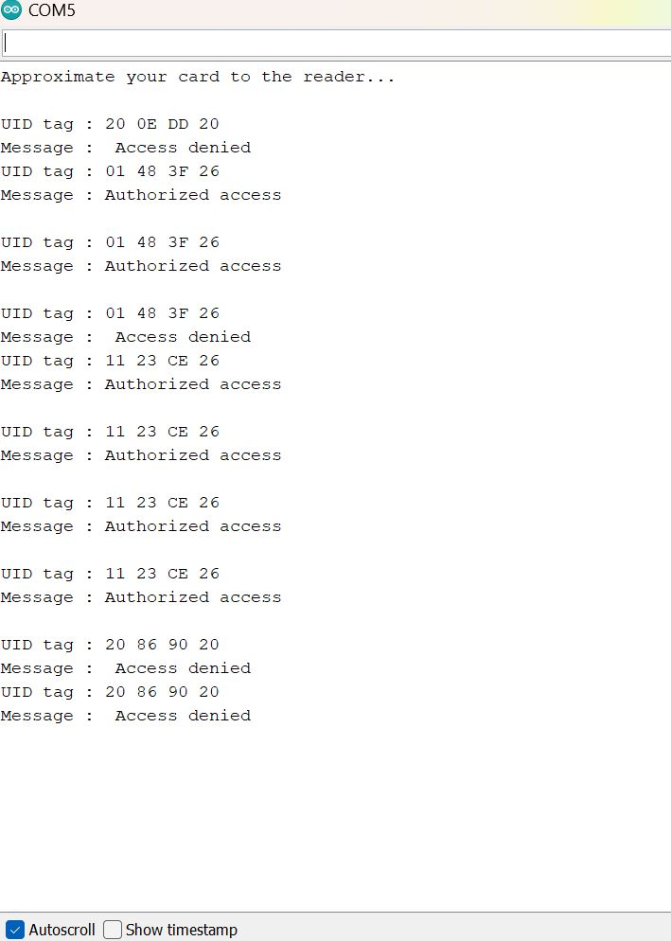

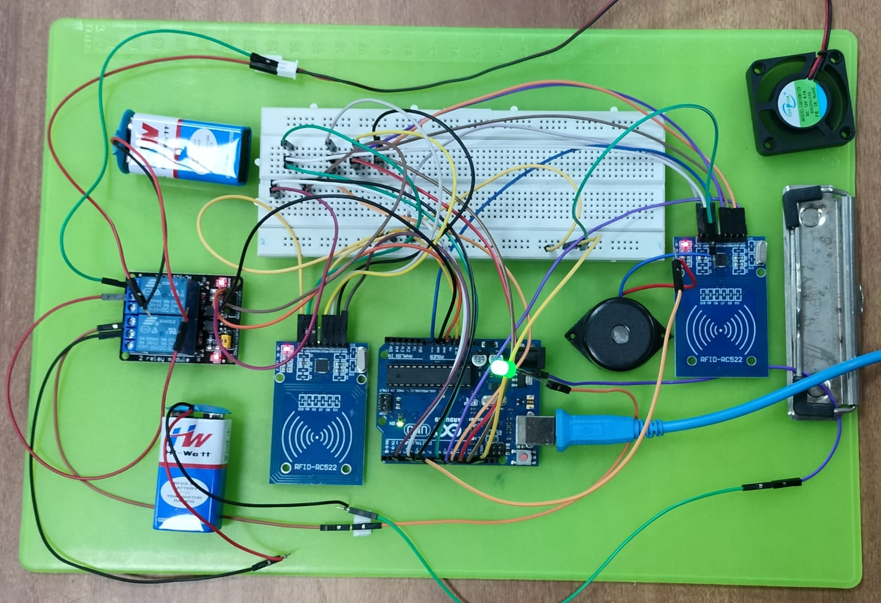

After placing RFID card near the RFID sensor LED stops glowing

